Visualizing Housing Market Trends: An Analysis of Sale Prices and
Features using Tableau
- INTRODUCTION
  - Project Overview:

This project analyzes housing market trends by exploring property sale prices and key features such as renovations, bedrooms, bathrooms, and house age using Tableau. By leveraging interactive visualizations, it aims to simplify complex housing data and support strategic decision-making for real estate analysts, marketers, and company executives.
  - Purpose:

To visualize electricity consumption patterns and empower smarter, data-driven energy decisions for a sustainable future.

IDEATION PHASE

  - Problem Statement
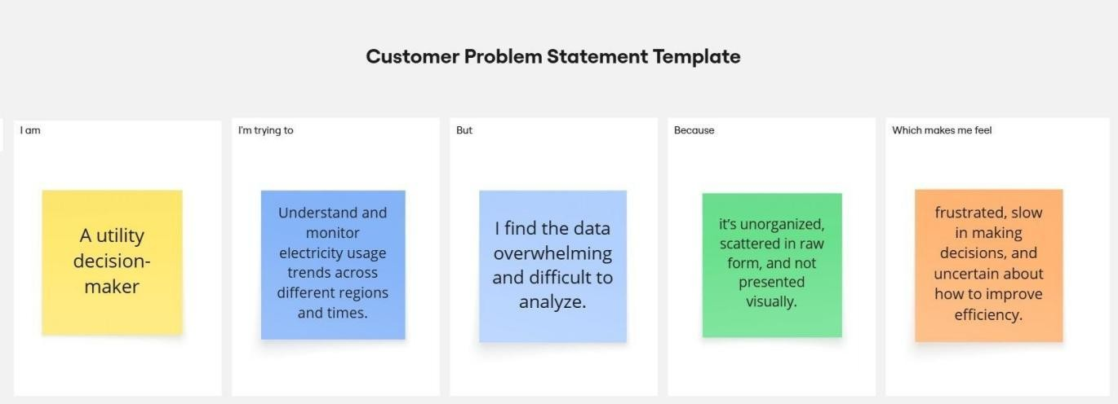

Problem Statement(PS) | I am (Customer) | I’m trying to | But | Because | Which makes me feel
PS-1 | A real estate analyst at ABC Company | identify factors affecting house prices and features | the dataset is large and hard to interpret | it lacks clear visualizations and segmentation | overwhelmed and unsure where to focus
PS-2 | A marketing  team | understand sales trends by renovation and house features | data is spread across multiple tables with limited insights | it hasn’t been structured for easy storytelling | confused and unable to create compelling campaigns
 | member
 | planning
 | pricing
 | strategies

  - Empathy Map Canvas
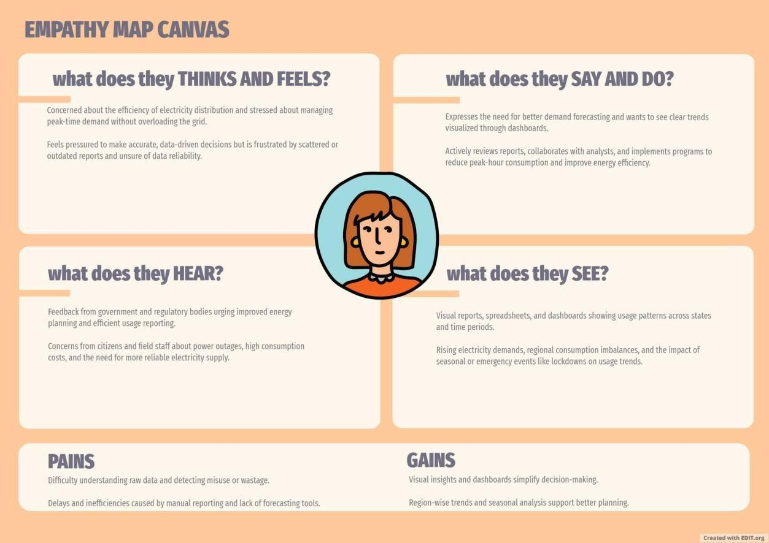

  - Brainstorming

Idea | Idea Description | Group/Category
1 | Show total records, average sale price, and total basement area | Time Patterns
2 | Visualize total sales by years since renovation using histogram | Yearly Comparison
3 | Pie chart of house age distribution by renovation status | Regional Insights
4 | Bar chart showing house age vs. bathrooms, bedrooms, and floors | Event Impact (COVID)
5 | Add calculated fields like average age and price difference | Visualization Techniques
6 | Use filters for renovation status, age range, and price bands | Deployment / Web Integration
7 | Use Tableau Story to explain renovation and price trends | Narrative & Communication
8 | Show KPIs like avg. price (renovated vs. non-renovated), house area | Dashboard Interactivity
9 | Publish and embed dashboard for internal/external sharing | Seasonal Analysis
10 | Forecast price trends using historical data | Data Processing / KPIs

REQUIREMENT ANALYSIS
  - Customer Journey map
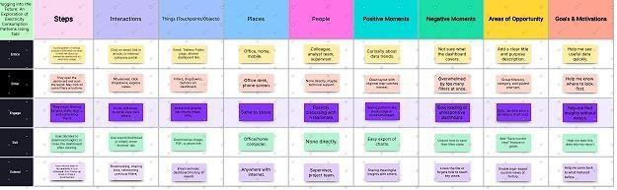

  - Solution Requirement

FR No. | Functional Requirement (Epic) | Sub Requirement (Story / Sub-Task)
FR-1 | User Registration | Registration through Form Registration through Gmail Registration through LinkedIn
FR-2 | User Confirmation | Confirmation via Email Confirmation via OTP
FR-3 | Data Upload & Storage | Upload CSV File  Store into MySQL Database
FR-4 | Data Visualization | Create visualizations in Tableau  Integrate with dashboard Age,year charts
FR-5 | Dashboard Access | View interactive Tableau dashboard Use filters (Year, Region)
FR-6 | Web Integration | Embed Tableau dashboard into Flask-based UI
FR-7 | Insights & Reports | View data stories  Access summary reports on usage patterns
FR No. | Non-Functional Requirement | Description
NFR-1 | Usability | Interface should be intuitive and user-friendly for both technical and non-technical users
NFR-2 | Security | Secure login with OTP/Email, protected data access
NFR-3 | Reliability | System should consistently provide correct visualizations
NFR-4 | Performance | Dashboards should load within 3–5 seconds even for larger datasets
NFR-5 | Availability | The platform should be available 24/7 without major downtime
NFR-6 | Scalability | Should support addition of new datasets and visualizations

  - Data Flow Diagram

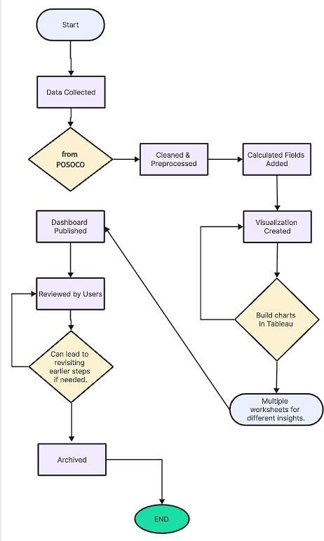

  - Technology Stack
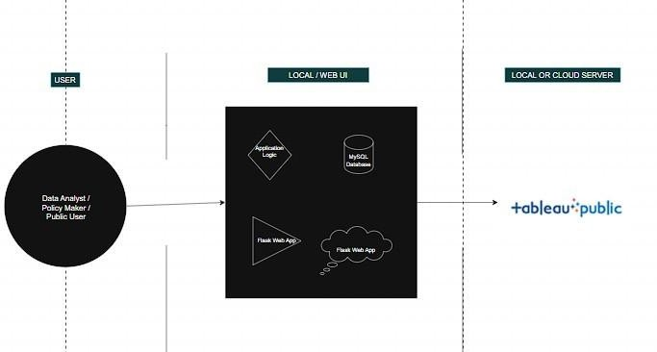

PROJECT DESIGN
  - Problem Solution Fit
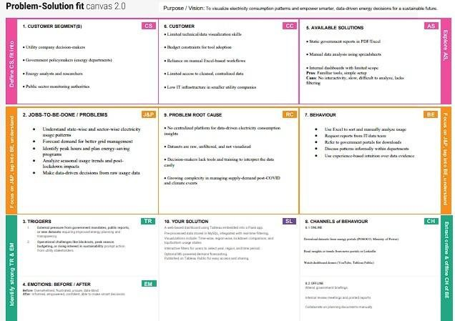
  - Proposed Solution

S.N  o. | Parameter | Description
1 | Problem Statement | Understanding the housing market is challenging due to scattered and non-visual datasets. Real estate analysts and executives struggle to identify the factors affecting house prices and renovation trends, impacting pricing strategies and planning.
2 | Idea / Solution Description | Our solution uses Tableau to transform raw housing sales data into insightful visual dashboards. The data is cleaned and filtered to highlight renovation age, number of rooms, and house features, enabling deeper analysis through charts like histograms and pie charts.
3 | Novelty / Uniqueness | Unlike basic spreadsheets, this solution offers interactive, filter-driven visual exploration. It allows users to see correlations like price changes post-renovation, trends based on the number of bathrooms or floors, and patterns by house age.
4 | Social Impact / Customer Satisfaction | The dashboard empowers real estate teams to make data-driven decisions, optimize pricing, and identify market trends. It brings clarity to complex data, supporting both business planning and strategic decision-making.
5 | Business Model (Revenue Model) | This project can be extended as a decision-support tool for real estate firms. Value-added features like predictive pricing or renovation impact analysis can be monetized for clients  and stakeholders.
6 | Scalability of the Solution | The solution is scalable to other real estate markets by integrating regional housing datasets. It can be expanded to include new features, geographies, or predictive analytics

  - Solution Architecture

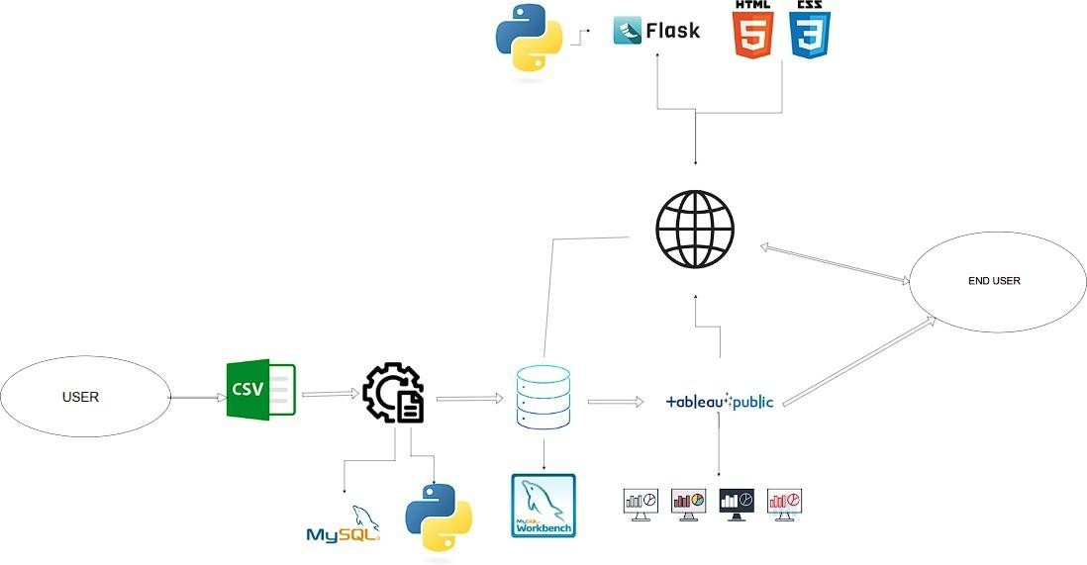

PROJECT PLANNING & SCHEDULING
  - Project Planning

Sprint | Epic | User Story No. | User Story / Task | Points | Priority | Assigned To
Sprint- 1 | Registration | USN-1 | As a user, I can register with my name and email | 2 | High | Nimmagadda Lakshman Kumar
Sprint- 1 | Upload CSV | USN-2 | As a user, I can upload electricity data in CSV format | 3 | High | Koka Sarath Mahesh
Sprint- 1 | Data Cleaning | USN-3 | As a developer, I can clean and preprocess uploaded data using Python | 4 | High | Nimmagadda Lakshman Kumar
Sprint- 1 | Database Storage | USN-4 | As a developer, I can store cleaned data into MySQL | 2 | Low | Kollipara Venkata Sai Karthik
Sprint- 2 | Tableau Dashboard | USN-5 | As a user, I can view dashboards generated using Tableau | 5 | High | Nidamanuri Sohith Kumar
Sprint- 2 | Web Integration | USN-6 | As a user, I can access the dashboard via Flask UI | 3 | High | Nimmagadda Lakshman Kumar
Sprint- 2 | Add Filters | USN-7 | As a user, I can filter the data by region, year, and quarter | 2 | Medium | Koka Sarath Mahesh
Sprint- 3 | Data Story | USN-8 | As a user, I can view a Tableau Story with key electricity usage insights | 2 | Low | Nimmagadda Lakshman Kumar
Sprint- 3 | Forecasting | USN-9 | As a developer, I can forecast usage using Prophet | 3 | Low | Nimmagadda Lakshman Kumar
Sprint- 3 | Documentation | USN-10 | As a team, we can prepare final project documentation | 2 | Medium | Koka Sarath Mahesh
Sprint- 4 | Deployment | USN-11 | As a developer, I can deploy the Flask app and publish the Tableau dashboard online | 3 | High | Nimmagadda Lakshman Kumar
Sprint- 4 | Demo Prep | USN-12 | As a team, we can prepare a live demo walkthrough for stakeholders | 2 | Medium | Kollipara Venkata Sai Karthik
Sprint- 4 | Bug Fixing | USN-13 | As a developer, I can test and fix UI/visual bugs from user feedback | 2 | Medium | Nidamanuri Sohith Kumar

FUNCTIONAL AND PERFORMANCE TESTING
  - Performance Testing

S.No  . | Parameter | Screenshot / Values
1. | Data Rendered | Dataset contains information about houses, including their price, area, number of bedrooms and bathrooms, and features like parking, furnishing status, and amenities, which can be used for real estate analysis in Tableau
2. | Data Preprocessin g | Null values handled, filtered for required years. This was done using Python (Pandas) and stored in MySQL before importing into Tableau.
3. | Utilizationof Filters | Filters applied in dashboard:  - Region  - State  - Year  - Quarter  - Lockdown (Yes/No)  Used across all dashboards to enhance interactivity. |  | 4 | Calculated Fields Used | Created fields in Tableau:  - Year(Date)  - Month(Date)  - Quarter(Date)  - Lockdown Label for categorizing data before and after lockdown.  - Top N States (for usage comparison). |  | 5 | Dashboard Design | Number of Visualizations: 3 Dashboards Each dashboard includes:  - Line Chart (Monthly trends)  - Bar Chart (State-wise comparison)  - Map / Tree Map (Region-wise consumption)  - KPI indicators (Total and Average Usage) R•efˆerú: Sc`reúenshotsof Dashboard.pdf |  | 6 | Story Design | Number of Slides/Graphs in Story: 15 Covers:  - Intro & Problem  - State-wise Usage  - Lockdown Comparison

    - Regional Patterns
    - Seasonal Trends
    - Insights + Conclusion

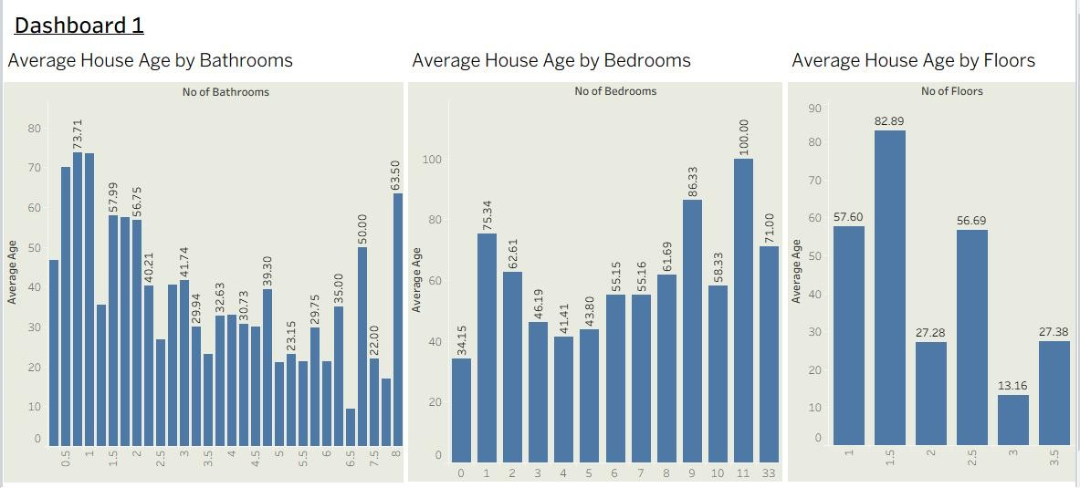
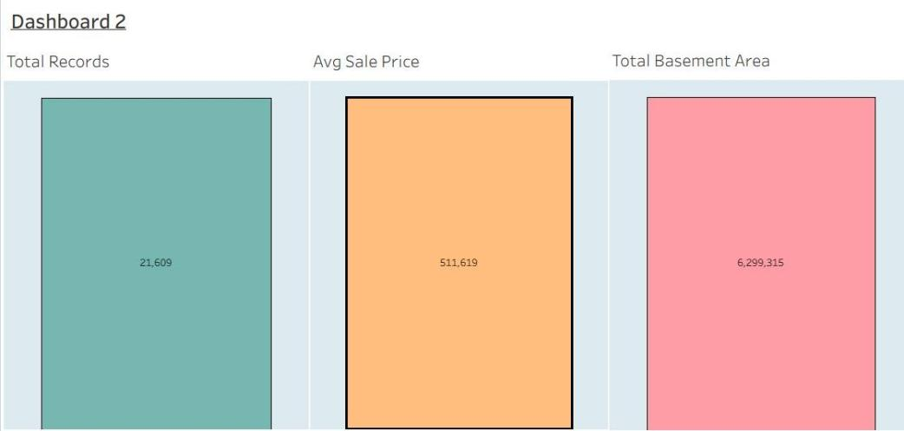
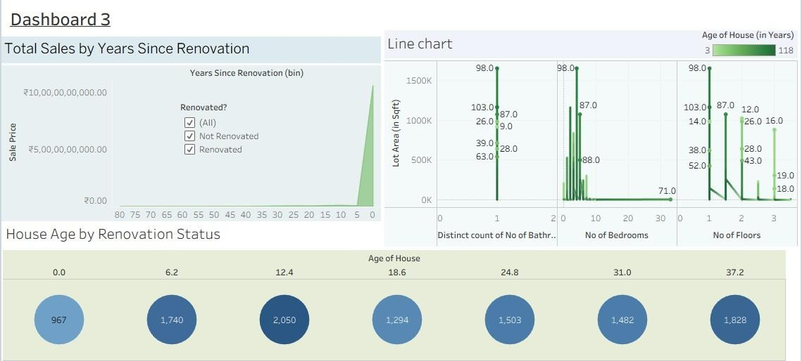
5. Dashboard design

No of Visualizations / Graphs - 3 Dashboards , 8 Visualizations / Graphs.

 |  | 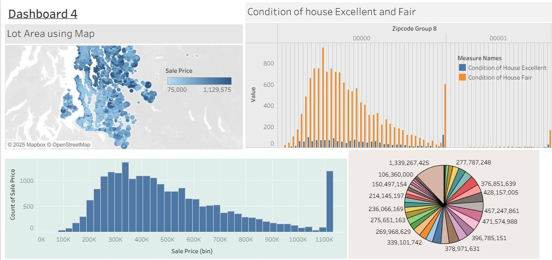
6 | Story Design | No of Visualizations / Graphs -15 slides.  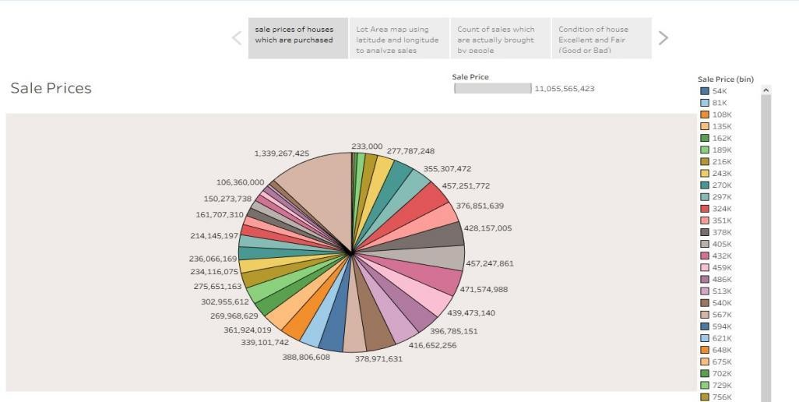  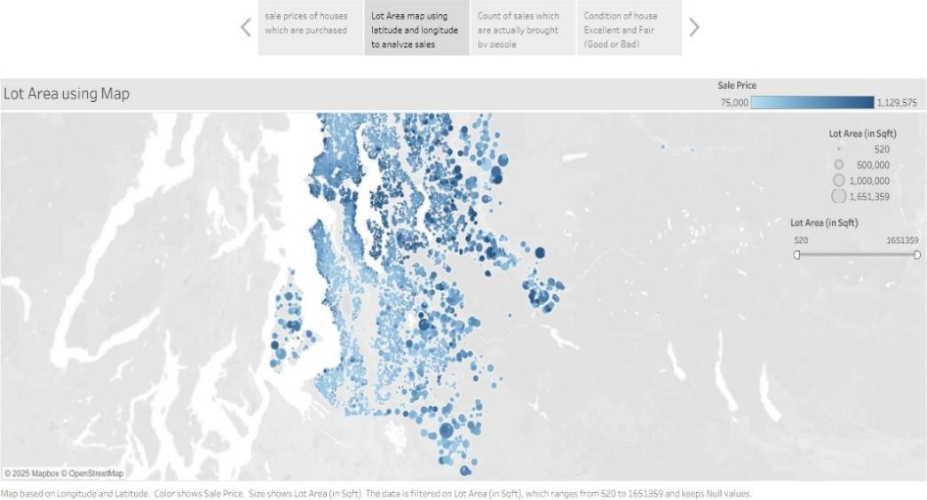

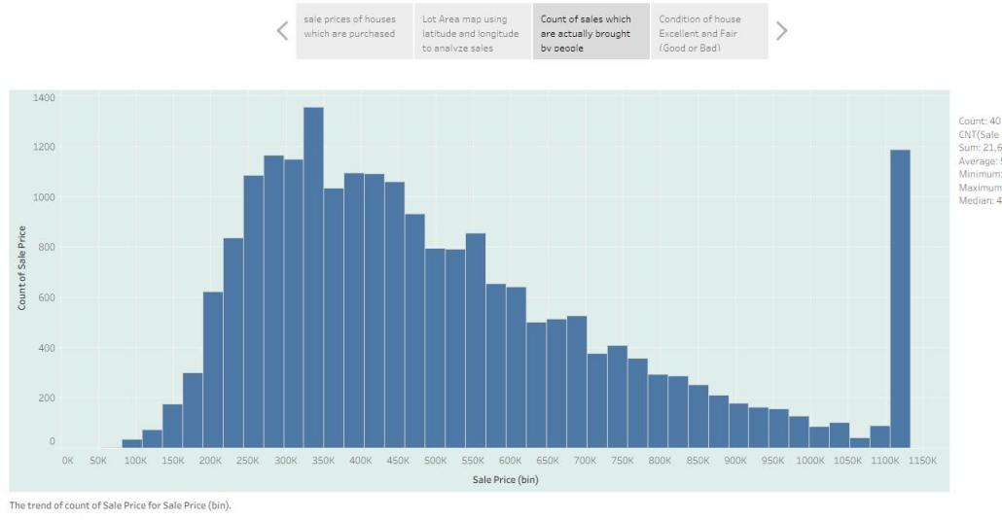

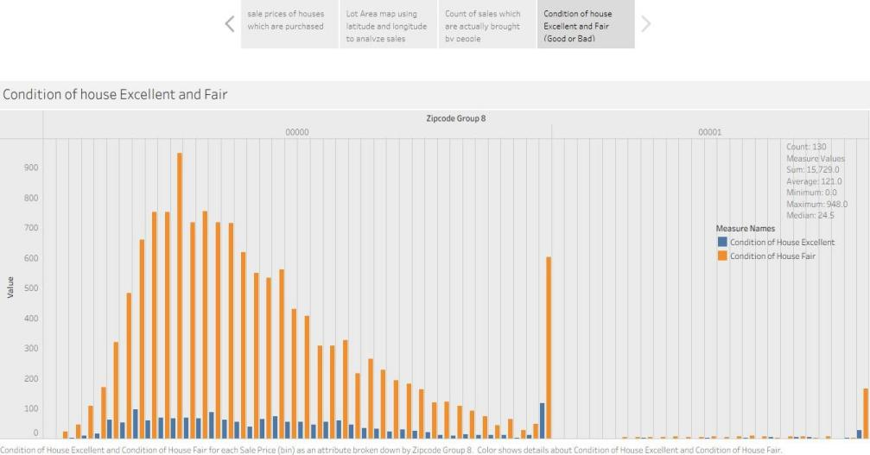

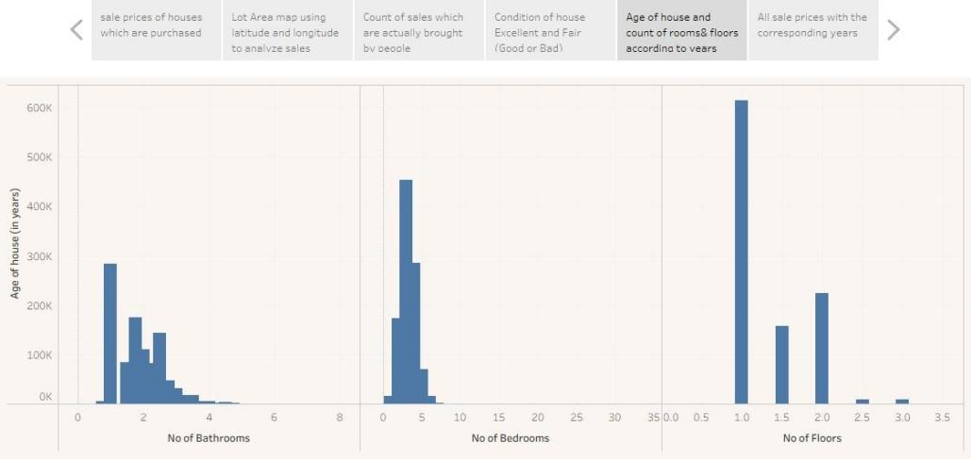

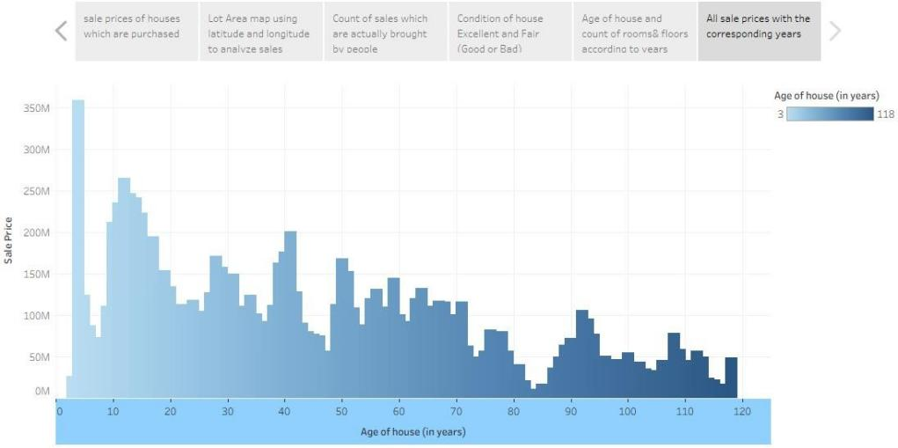

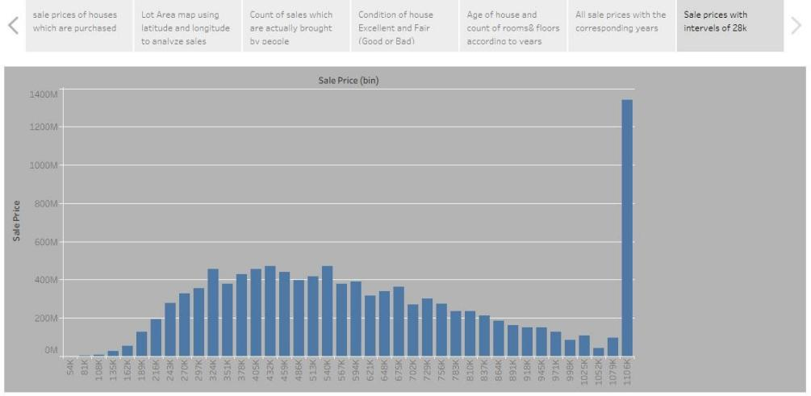

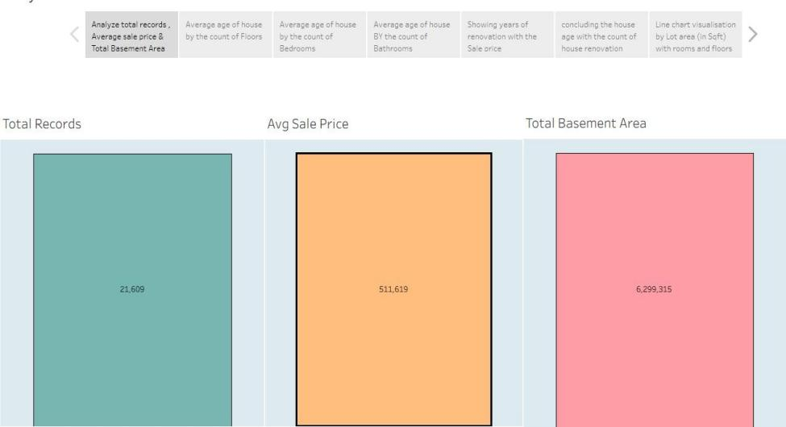

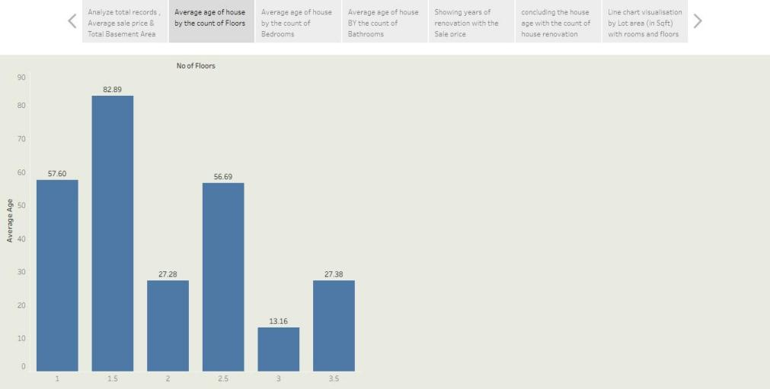

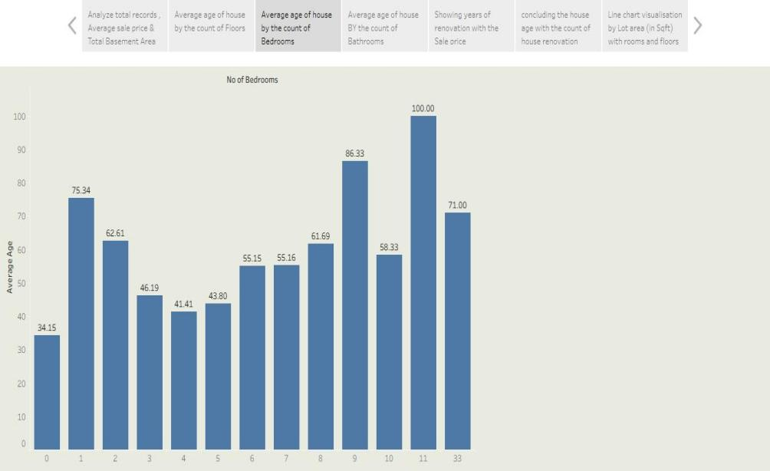

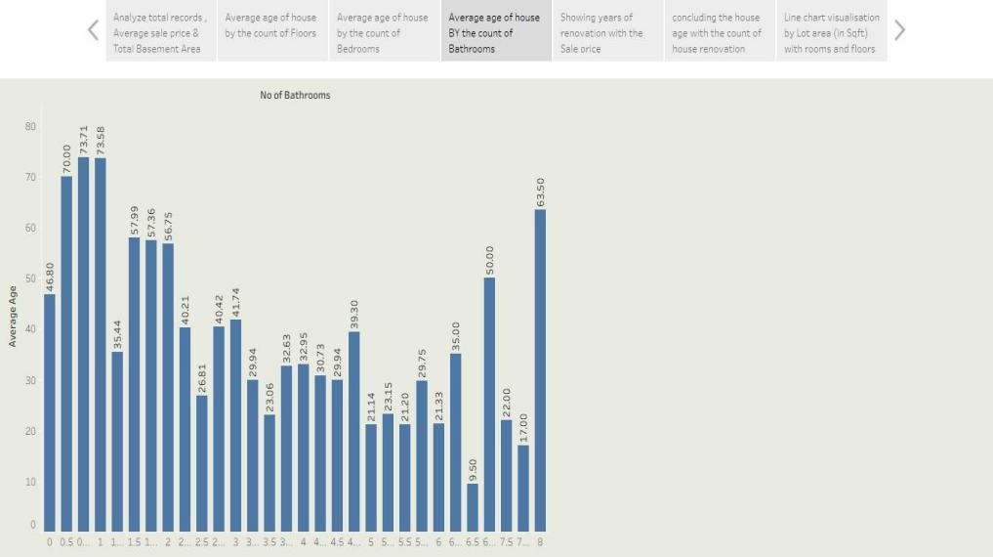

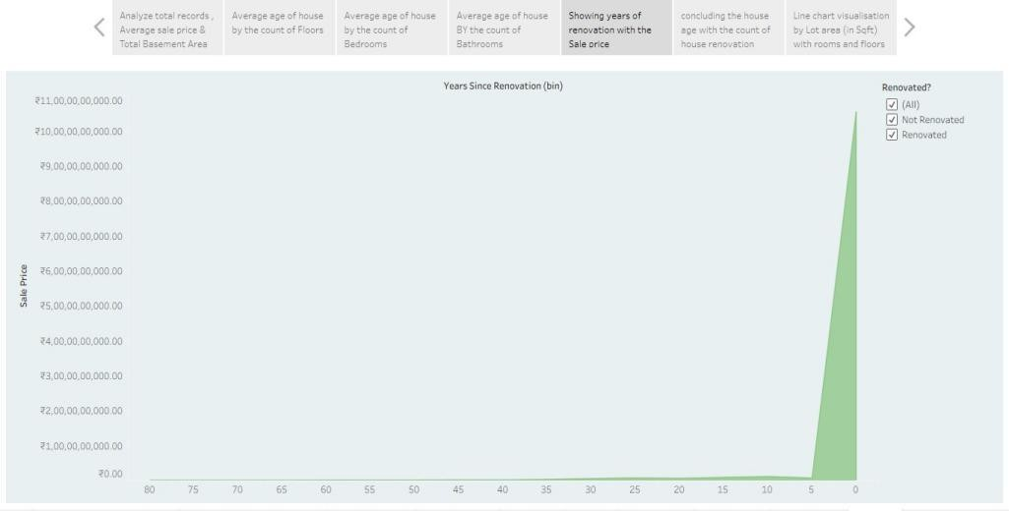

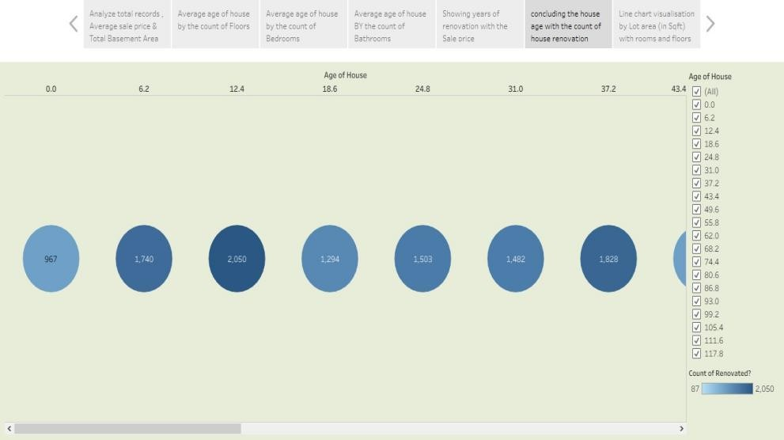

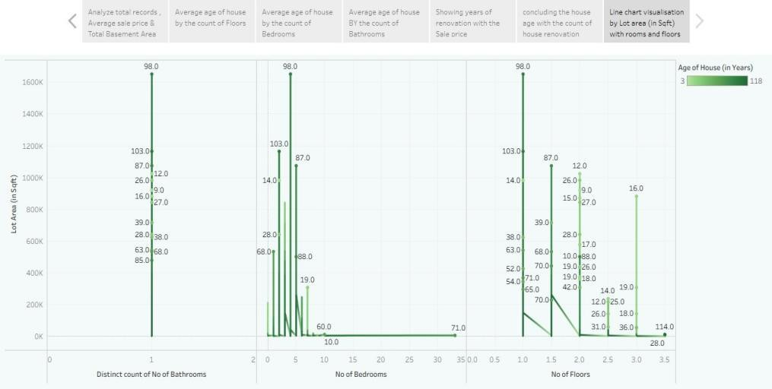

RESULTS
  - Output Screenshots

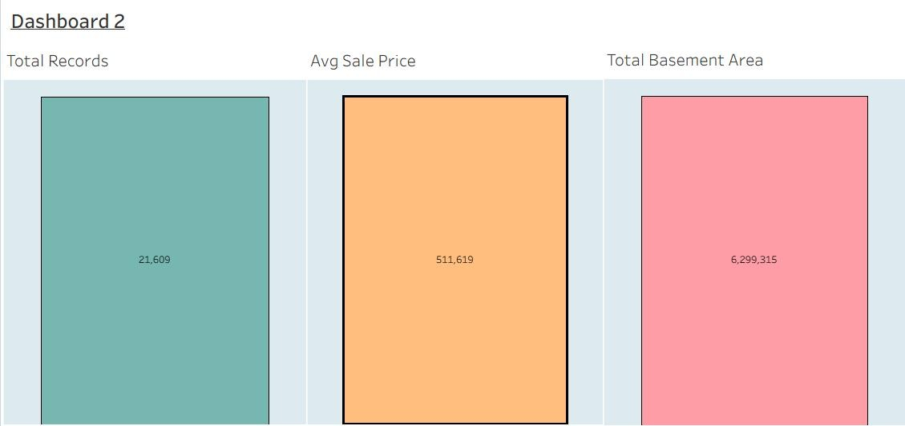





ADVANTAGES & DISADVANTAGES

Advantages | Disadvantages
Free, open-source technology stack | Depends on Tableau Public hosting
Visually rich dashboards with no coding | Manual data upload (not automated)
Easy to scale and reuse with other datasets | Limited customization in Tableau Public
Interactive filters and storytelling | Requires stable internet for live dashboards

- CONCLUSION
The project successfully demonstrated how data visualization can transform complex housing sales data into actionable insights. Stakeholders can now make informed pricing and market decisions backed by clear trends in renovation impact, house features, and sales patterns..

FUTURE SCOPE

- Automate data updates from real estate listing platforms or Excel feeds
- Integrate predictive pricing models using machine learning
- Extend analysis to include rental trends and property tax insights
- Develop a mobile-responsive version of the dashboard for on-the-go analysis

APPENDIX
Source Code : NIL
Dataset link :
https://docs.google.com/spreadsheets/d/1Aeug2Xc6gim8fUmveDm8Z Gi44t7MmWfr/edit?usp=drivesdk&ouid=113831785895254557512&rtp of=true&sd=true
Demovideo link :
https://drive.google.com/file/d/1heqHcFrQfN1AY7UYvLRYKz9KxODzcw_i/view?usp=sharing

